**Lab B week 11**

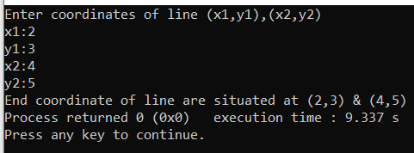Q1. #include<stdio.h>

struct line{

int x1;

int y1;

int x2;

int y2};

int main(){

struct line l1;

printf("Enter coordinates of line (x1,y1),(x2,y2)\n");

printf("x1:");

scanf("%d",&l1.x1);

printf("y1:");

scanf("%d",&l1.y1);

printf("x2:");

scanf("%d",&l1.x2);

printf("y2:");

scanf("%d",&l1.y2);

printf("End coordinate of line are situated at (%d,%d) & (%d,%d)",l1.x1,l1.y1,l1.x2,l1.y2);

}

Q2. #include<stdio.h>

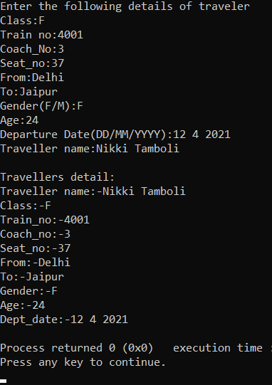#include<string.h>

struct traveller{

char Class;

int train_no;

int coach_number;

int seat_no;

char from[40];

char to[40];

char gender;

int age;

char dept_date[20];

char traveller_name[40];

};

struct traveller Ticket1(){

char a[40];

char b[40];

char c[40];

char d[40];

struct traveller T1;

printf("Enter the following details of traveler\n");

printf("Class:");

scanf("%c",&T1.Class);

printf("Train no:");

scanf("%d",&T1.train_no);

printf("Coach_No:");

scanf("%d",&T1.coach_number);

printf("Seat_no:");

scanf("%d",&T1.seat_no);

printf("From:");

scanf("%s",&a);

getchar();

strcpy(T1.from,a);

printf("To:");

scanf("%s",&b);

getchar();

strcpy(T1.to,b);

printf("Gender(F/M):");

scanf("%c",&T1.gender);

getchar();

printf("Age:");

scanf("%d",&T1.age);

getchar();

printf("Departure Date(DD/MM/YYYY):");

gets(c);

strcpy(T1.dept_date,c);

printf("Traveller name:");

gets(d);

strcpy(T1.traveller_name,d);

printf("\n");

return T1;

};

void display(struct traveller T1){

printf("Travellers detail:\n");

printf("Traveller name:-%s\nClass:-%c\nTrain_no:-%d\nCoach_no:-%d\nSeat_no:-%d\nFrom:-%s\nTo:-%s\nGender:-%c\nAge:-%d\nDept_date:-%s\n",T1.traveller_name,T1.Class,T1.train_no,T1.coach_number,T1.seat_no,T1.from,T1.to,T1.gender,T1.age,T1.dept_date);

}

int main()

{

struct traveller T1;

T1=Ticket1();

display(T1);

return 0;

}

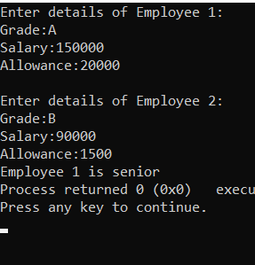

Q3. #include<stdio.h>

struct Employee{

char grade;

int salary;

int allowance;

};

int main(){

struct Employee E1,E2;

printf("Enter details of Employee 1:\n");

printf("Grade:");

scanf("%c",&E1.grade);

printf("Salary:");

scanf("%d",&E1.salary);

printf("Allowance:");

scanf("%d",&E1.allowance);

printf("\n");

printf("Enter details of Employee 2:\n");

printf("Grade:");

getchar();

scanf("%c",&E2.grade);

printf("Salary:");

scanf("%d",&E2.salary);

printf("Allowance:");

scanf("%d",&E2.allowance);

if((int)E1.grade<(int)E2.grade)

{

printf("Employee 1 is senior");

}

else if((int)E1.grade>(int)E2.grade){

printf("Employee 2 is senior");

}

Else

{

printf("Both are same grade");

}

return 0;

}

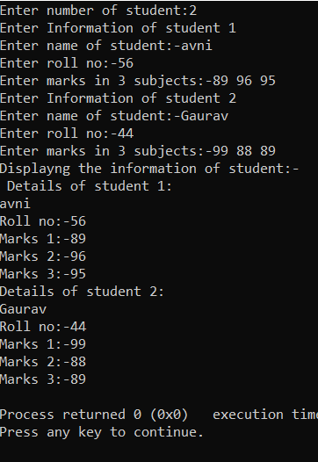Q4. #include<stdio.h>

struct student{

char name[50];

int rollno;

int marks[50];

};

int main(){

int n;

struct student s[20];

printf("Enter number of student:");

scanf("%d",&n);

for(int i=1;i<=n;i++){

printf("Enter Information of student %d\n",i);

printf("Enter name of student:-");

scanf("%s",s[i].name);

printf("Enter roll no:-");

scanf("%d",&s[i].rollno);

printf("Enter marks in 3 subjects:-");

for(int j=1;j<=3;j++){

scanf("%d",&s[i].marks[j]);}

}

printf("Displayng the information of student:-\n ");

for(int i=1;i<=n;i++){

printf("Details of student %d:\n",i);

puts(s[i].name);

printf("Roll no:-%d\n",s[i].rollno);

for (int j=1;j<=3;j++){

printf("Marks %d:-%d\n",j,s[i].marks[j]);

}

}

}

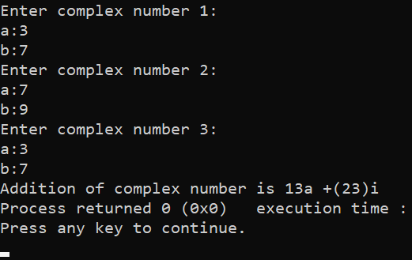Q5. #include<stdio.h>

struct complex1{

int a;

int b;

};

struct complex2{

int a;

int b;

};

struct complex3{

int a;

int b;

};

int addition(struct complex1 eq1,struct complex2 eq2,struct complex3 eq3){

int sum1;

int sum2;

printf("Enter complex number 1:\n");

printf("a:");

scanf("%d",&eq1.a);

printf("b:");

scanf("%d",&eq1.b);

printf("Enter complex number 2:\n");

printf("a:");

scanf("%d",&eq2.a);

printf("b:");

scanf("%d",&eq2.b);

printf("Enter complex number 3:\n");

printf("a:");

scanf("%d",&eq3.a);

printf("b:");

scanf("%d",&eq3.b);

sum1=eq1.a+eq2.a+eq3.a;

sum2=eq1.b+eq2.b+eq3.b;

printf("Addition of complex number is %da +(%d)i",sum1,sum2);

return 0;

}

int main(){

struct complex1 eq1;

struct complex2 eq2;

struct complex3 eq3;

addition(eq1,eq2,eq3);

return 0;

}